Project: Bacterial Fine-Tuning of InstaNovo for Large-Scale Wastewater Proteomics
Wenjing Yang
1 Introduction
Mass spectrometry (MS)-based proteomics is a major tool for large-scale protein analysis, and database search is the dominant method for peptide identification by matching experimental MS/MS spectra to theoretical spectra[1], [2]. However, this method faces problems like a strong dependence on the chosen database, long search times, and a large search space[3]. In contrast, de novo peptide sequencing infers peptide sequences directly from mass differences between fragment peaks, making it promising for identifying uncharacterized proteins without reference databases[4]. But traditional de novo methods often led to high computational costs and high false discovery rates[5], [6].
Recently, with the rapid development of AI and mass spectrometry technologies, transformer-based models for de novo peptide sequencing have shown strong potential in proteomics. For example, the InstaNov and InstaNov+ got excellent performance by learning complex relationships between MS/MS spectra and peptide sequences [7], [8], [9]. In particular, by using multi-scale sinusoidal embeddings to encode MS peaks, these models make significant progress in learning peak patterns and precursor information that improves a lot on precision and recall for peptide prediction[10]. By the combination of AI technologies with proteomics, it may reduce the dependence on database searching methods that can be used for more complex samples without choosing specific databases, and predict unknown proteins. However, existing studies have mainly focused on human protein datasets, and their applicability to complex environmental samples remains unclear.
Therefore, this project aims to fine-tune InstaNovo for large-scale bacterial proteomics to improve the speed and accuracy of protein identification and thereby support the deeper understanding of bacterial functions in wastewater.
2 Methods and Data
Methods. This project used a supervised transfer-learning model based on InstaNovo to predict peptide sequences [7]. Starting from the official pretrained model, the fine-tune model will be modified by filtered wastewater bacterial proteomics data (Fig.1). The model takes MS/MS spectra (mass-to-charge ratio and intensity) and precursor features (precursor mass and charge) as inputs, and the corresponding peptide sequence as output. The model will be evaluated by peptide-level accuracy, amino acid-level recal.
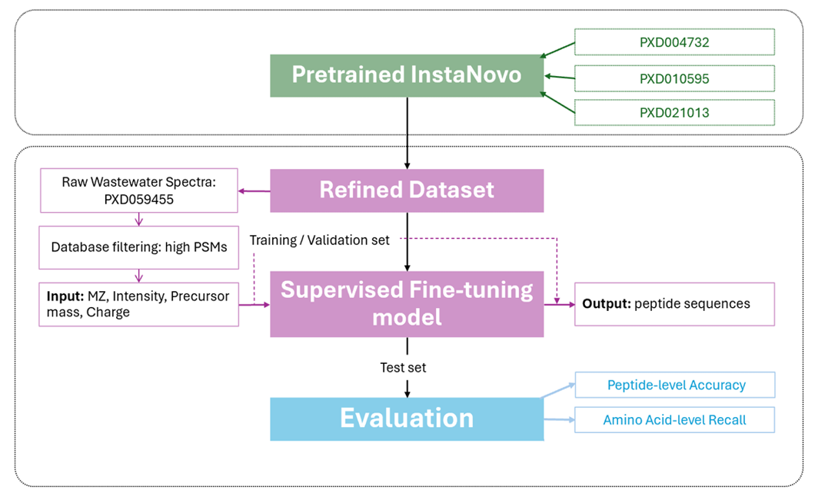
Figure 1 Pipeline of the fine-tuning model
Data resource. The official pretrained InstaNovo model was trained on the ProteomeTools dataset of synthetic peptides derived from human proteins, which can be found in the PRIDE repository with identifiers PXD004732 (Part I), PXD010595 (Part II), and PXD021013 (Part III)[7], [11]. It contains over 700,000 synthetic peptides from human proteins, isoforms, alternative proteases, and HLA peptides, and the peptide-spectrum matches (PSMs) were extracted to construct high-confidence and all-candidate datasets for model training. My model is then fine-tuned on bacterial proteomics data derived from wastewater samples in PXD059455[12]. This dataset includes 20 raw files, with samples collected over three months from two urban locations. These wastewater samples contain diverse microbes, including gut bacteria and opportunistic pathogens, and around 200 human proteins associated with health and disease biomarkers.
Data preprocessing. In this project, the training dataset was built from raw MS data using the traditional MaxQuant database search method (Fig.2). First, the proteomics database for MaxQuant was selected and prepared. The bacterial database was built based on a previous study of the same PXD059455 dataset[12]. It applied a wastewater metaproteomics pipeline with de novo sequencing to refine generic reference databases. Based on the dominant microbial orders and families reported in that study, three representative species were selected for each bacterial family. The final database contained 12 orders, 35 representative species, and 144,457 protein sequences downloaded from UniProt[13]. Second, a reliable training dataset by filtering high-confidence PSMs was built. PSMs were filtered using posterior error probability (PEP) ≤ 0.02 and score ≥ 60, while noise and contaminants were removed. 4,123 peptide-spectrum matches, and 965 high-confidence spectra were retained and saved in MGF format. Third, the data information was integrated into one table. The InstaNovo training table was built by linking the peptide sequence, scan number, and spectrum information. Finally, the data were split into training, validation, and test sets using a 70/15/15 ratio. The files were then converted into the format required by the model.
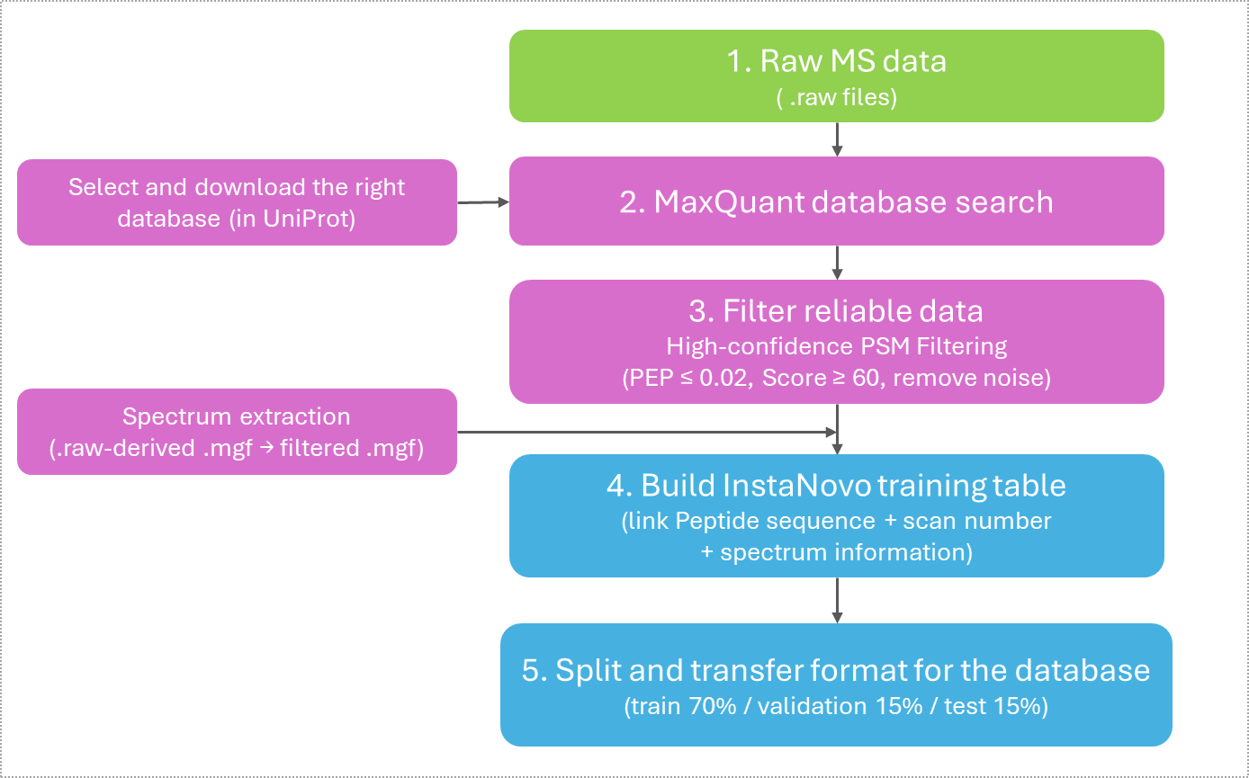
Figure 2 Workflow of data preprocessing
3 Model
Model introduction. In this project, InstaNovo was used as the pre-trained model for de novo peptide sequencing. InstaNovo is a supervised deep learning model based on a transformer encoder-decoder architecture. The encoder takes the MS/MS spectrum as input and learns the peak information, while the decoder generates the peptide sequence step by step. In this way, the model performs sequence generation through token-level prediction. The model contains 9 encoder layers and 9 decoder layers, with a hidden dimension of 768. It also uses 16 attention heads to learn the relationships between spectrum peaks and peptide tokens, with a feed-forward dimension of 2048. The total number of parameters is about 94.6 million. During training, cross-entropy loss is used to optimize the model.
Fine-tuning and improvement of the model. The model was initialized from the pre-trained checkpoint `instanovo-v1.2.0.ckpt` following the InstaNovo getting started workflow[7]. For fine-tuning, the training partition was set to `train`, the validation partition was set to `val`, and the train and prediction batch sizes were both set to 4. The learning rate was set to 1e-7, and the model was trained for 10 steps. Validation and checkpoint saving were performed every 10 steps. To improve the model, conservative hyperparameters of fine-tuning settings were used, including a small learning rate, limited training steps, and a small batch size. In addition, layer freezing was applied during fine-tuning. All model parameters were frozen except the `peak_encoder`, so the model could adapt to the wastewater spectra without changing most of the pre-trained weights.
4 Results
The fine-tuned model did not improve the prediction results compared with the official InstaNovo model (see Table 1). On the test set of 146 spectra, the official model achieved a 20 parts per million (ppm) pass rate of 79.45%, while the fine-tuned model only achieved 0.68%. In addition, the official model had 25 exact sequence matches, while the fine-tuned model had none. Another important observation is that the fine-tuned model predicted modification-containing peptides for 145 out of 146 spectra, suggesting strong over-prediction of modification tokens. Overall, these results show that the fine-tuned model failed to generalize well to the test data.
Table 1: Evaluation between the InstaNovo model and the fine-tuned model
Metric | Official InstaNovo Model | Fine-tuned Model
Test spectra | 146 | 146
20 ppmpass rate | 79.45% | 0.68%
Number of spectra passing 20 ppm | 116 / 146 | 1 / 146
Exact sequence matches | 25 / 146 | 0 / 146
Exact sequence match rate | 17.12% | 0%
Predictions with modifications | 21 / 146 | 145 / 146

5 Discussion and Conclusion
The fine-tuned model finished training successfully, but it did not generalize well on the test data. Compared with the official InstaNovo model, the fine-tuned model produced larger precursor mass errors and predicted too many modification-containing peptides. This shows that fine-tuning did not improve the model's performance in this setting.
There are several possible reasons for this result. First, the fine-tuning dataset was very small compared with the large model size, so the model may not have had enough data to learn stable patterns. Second, although most parameters were frozen, only updating the `peak_encoder` could still change how the model represents spectra. Third, wastewater proteomics data may have a different distribution from the original InstaNovo training data. Finally, the model tended to over-predict modification tokens such as `UNIMOD:21`, which may have increased prediction errors.

Reference
[1] R. Aebersold and M. Mann, “Mass-spectrometric exploration of proteome structure and function,” Nature, vol. 537, no. 7620, pp. 347–355, Sep. 2016, doi: 10.1038/nature19949.
[2] A. Keller, A. I. Nesvizhskii, E. Kolker, and R. Aebersold, “Empirical Statistical Model To Estimate the Accuracy of Peptide Identifications Made by MS/MS and Database Search,” Anal. Chem., vol. 74, no. 20, pp. 5383–5392, Oct. 2002, doi: 10.1021/ac025747h.
[3] F. Bugyi et al., “Influence of Post-Translational Modifications on Protein Identification in Database Searches,” ACS Omega, vol. 6, no. 11, pp. 7469–7477, Mar. 2021, doi: 10.1021/acsomega.0c05997.
[4] A. Frank and P. Pevzner, “PepNovo: De Novo Peptide Sequencing via Probabilistic Network Modeling,” Anal. Chem., vol. 77, no. 4, pp. 964–973, Feb. 2005, doi: 10.1021/ac048788h.
[5] K. F. Medzihradszky and R. J. Chalkley, “LESSONS IN DE NOVO PEPTIDE SEQUENCING BY TANDEM MASS SPECTROMETRY,” Mass Spectrom. Rev., vol. 34, no. 1, pp. 43–63, 2015, doi: 10.1002/mas.21406.
[6] T. Muth and B. Y. Renard, “Evaluating de novo sequencing in proteomics: already an accurate alternative to database-driven peptide identification?,” Brief. Bioinform., vol. 19, no. 5, pp. 954–970, Sep. 2018, doi: 10.1093/bib/bbx033.
[7] K. Eloff et al., “InstaNovo enables diffusion-powered de novo peptide sequencing in large-scale proteomics experiments,” Nat. Mach. Intell., vol. 7, no. 4, pp. 565–579, Apr. 2025, doi: 10.1038/s42256-025-01019-5.
[8] A. Mabona et al., “De novo peptide sequencing rescoring and FDR estimation with Winnow,” Sep. 30, 2025, arXiv: arXiv:2509.24952. doi: 10.48550/arXiv.2509.24952.
[9] K. Eloff, A. Mabona, W. Williams, and J. Van Goey, InstaNovo. (Jan. 21, 2025). Zenodo. doi: 10.5281/zenodo.14712454.
[10] G. Voronov, R. Lightheart, J. Davison, C. A. Krettler, D. Healey, and T. Butler, “Multi-scale Sinusoidal Embeddings Enable Learning on High Resolution Mass Spectrometry Data,” May 05, 2023, arXiv: arXiv:2207.02980. doi: 10.48550/arXiv.2207.02980.
[11] D. P. Zolg et al., “Building ProteomeTools based on a complete synthetic human proteome,” Nat. Methods, vol. 14, no. 3, pp. 259–262, Mar. 2017, doi: 10.1038/nmeth.4153.
[12] C. G. Tugui, F. Cordesius, W. van Holthe, M. C. M. van Loosdrecht, and M. Pabst, “Wastewater metaproteomics: tracking microbial and human protein biomarkers,” ISME Commun., vol. 6, no. 1, p. ycaf243, Jan. 2026, doi: 10.1093/ismeco/ycaf243.
[13] The UniProt Consortium, “UniProt: the Universal Protein Knowledgebase in 2025,” Nucleic Acids Res., vol. 53, no. D1, pp. D609–D617, Jan. 2025, doi: 10.1093/nar/gkae1010.

